* **Linked list 8:**

Q /*linked queue as integer*/

**#include<iostream.h>**

**#include<conio.h>**

**struct node**

**{**

**int data;**

**node*next;**

**};**

**node*add(node*rear, int val);**

**node*Delete(node*front, int & val);**

**void show_q(node*front);**

**void main()**

**{**

**node*front,*rear;**

**front=rear=NULL;**

**int val,choice;**

**clrscr();**

**do**

**{**

**cout<<"\n main menu";**

**cout<<" 1.add";**

**cout<<" 2.delete";**

**cout<<" 3.show";**

**cout<<" 4.exit";**

**cout<<" enter you choice";**

**cin>>choice;**

**switch(choice)**

**{**

**case 1:cout<<"\n enter the value\t";**

**cin>>val;**

**rear=add(rear,val);**

**if(front==NULL)**

**front=rear;**

**break;**

**case 2:front=Delete(front,val);**

**if(val!=-9999)**

**cout<<"\n the deleted value is\t"<<val;**

**if(front==NULL)**

**rear=front;**

**break;**

**case 3:show_q(front);**

**break;**

**}**

**}while(choice!=4);**

**getche();**

**}**

**node*add(node*rear,int val)**

**{**

**node*x;**

**x=new node;**

**x->data=val;**

**x->next=NULL;**

**if(rear!=NULL)**

**rear->next=x;**

**rear=x;**

**return(rear);**

**}**

**node*Delete(node*front,int & val)**

**{**

**node*x;**

**if(front==NULL)**

**{**

**cout<<"\n queue is empty \n";**

**val=-9999;**

**}**

**else**

**{**

**x=front;**

**front=front->next;**

**val=x->data;**

**delete x;**

**}**

**return(front);**

**}**

**void show_q(node*front)**

**{**

**node*ptr;**

**ptr=front;**

**cout<<"\n the queue is:\n";**

**while(ptr!=NULL)**

**{**

**cout<<ptr->data<<"\t";**

**ptr=ptr->next;**

**}**

**}**

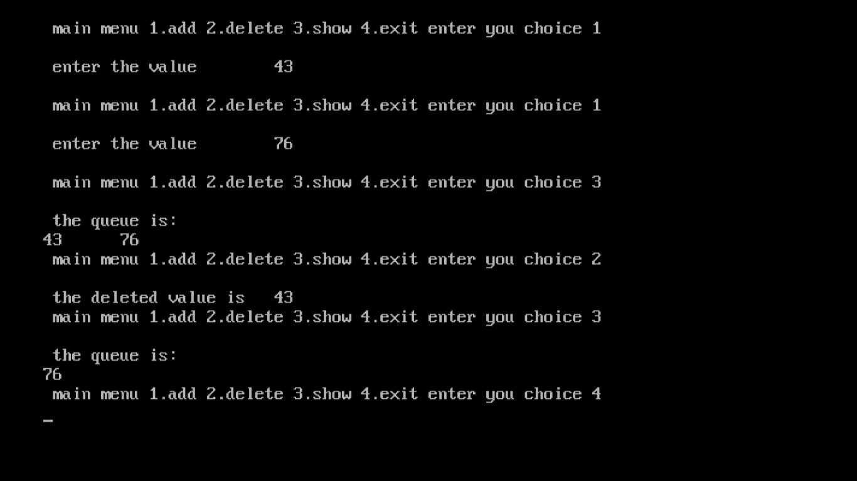

* **Linked list 9:**

Q /*linked queue as character */

**#include<iostream.h>**

**#include<conio.h>**

**#include<stdio.h>**

**#include<string.h>**

**struct node**

**{**

**char data[30];**

**node*next;**

**};**

**node*add(node*rear, char val[30]);**

**node*Delete(node*front, char val[30]);**

**void show_q(node*front);**

**void main()**

**{**

**node*front,*rear;**

**front=rear=NULL;**

**char val[30];**

**int choice;**

**clrscr();**

**do**

**{**

**cout<<"\n main menu";**

**cout<<" 1.add";**

**cout<<" 2.delete";**

**cout<<" 3.show";**

**cout<<" 4.exit";**

**cout<<" enter you choice";**

**cin>>choice;**

**switch(choice)**

**{**

**case 1:cout<<"\n enter the value\t";**

**gets(val);**

**rear=add(rear,val);**

**if(front==NULL)**

**front=rear;**

**break;**

**case 2:front=Delete(front,val);**

**if(strcmp(val,NULL)!=0)**

**cout<<"\n the deleted value is\t"<<val;**

**if(front==NULL)**

**rear=front;**

**break;**

**case 3:show_q(front);**

**break;**

**}**

**}while(choice!=4);**

**getche();**

**}**

**node*add(node*rear,char val[30])**

**{**

**node*x;**

**x=new node;**

**strcpy(x->data,val);**

**x->next=NULL;**

**if(rear!=NULL)**

**rear->next=x;**

**rear=x;**

**return(rear);**

**}**

**node*Delete(node*front,char val[30])**

**{**

**node*x;**

**if(front==NULL)**

**{**

**cout<<"\n queue is empty \n";**

**strcpy(val,NULL);**

**}**

**else**

**{**

**x=front;**

**front=front->next;**

**strcpy(val,x->data);**

**delete x;**

**}**

**return(front);**

**}**

**void show_q(node*front)**

**{**

**node*ptr;**

**ptr=front;**

**cout<<"\n the queue is:\n";**

**while(ptr!=NULL)**

**{**

**cout<<ptr->data<<"\t";**

**ptr=ptr->next;**

**}**

**}**

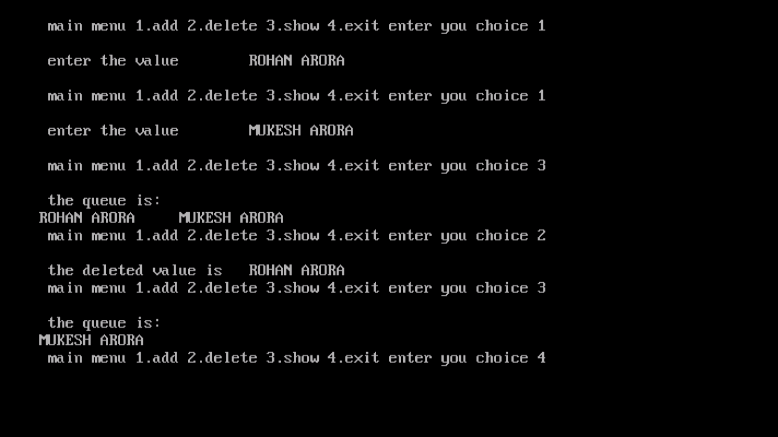

* **Linked list 10:**

Q /*linked queue with integer and character */

**#include<iostream.h>**

**#include<conio.h>**

**#include<stdio.h>**

**#include<string.h>**

**struct student**

**{**

**int rollno;**

**char name[30];**

**student*next;**

**};**

**student*add(student*rear,int val,char val1[20]);**

**student*Delete(student*front,int & val,char val1[20]);**

**void display(student*front);**

**void main()**

**{**

**clrscr();**

**student*front,*rear;**

**int choice;**

**int val;**

**char val1[20];**

**front=rear=NULL;**

**do**

**{**

**cout<<"\n main menu";**

**cout<<"\n 1. add rollno and name";**

**cout<<"\n 2. delete element";**

**cout<<"\n 3. display queue";**

**cout<<"\n 4. exit";**

**cout<<"\n Enter your choice";**

**cin>>choice;**

**switch(choice)**

**{**

**case 1:cout<<"\n enter rollno to be added in queue";**

**cin>>val;**

**cout<<"\n enter the students name";**

**gets(val1);**

**rear=add(rear,val,val1);**

**if(front==NULL)**

**front=rear;**

**break;**

**case 2:front=Delete(front,val,val1);**

**if(strcmp(val1,NULL)!=0)**

**{**

**cout<<"\n the deleted value is"<<"rollno:"<<val;**

**cout<<"\n name:"<<val1;**

**}**

**rear=front;**

**break;**

**case 3:display(front);**

**break;**

**}**

**}while (choice!=4);**

**getche();**

**}**

**student*add(student*rear,int val,char val1[20])**

**{**

**student*x;**

**x=new student;**

**x->rollno=val;**

**strcpy(x->name,val1);**

**x->next=NULL;**

**if(rear!=NULL)**

**rear->next=x;**

**rear=x;**

**return(rear);**

**}**

**student*Delete(student*front,int & val,char val1[20])**

**{**

**student*x;**

**if(front==NULL)**

**{**

**cout<<"\n the queue is empty";**

**strcpy(val1,NULL);**

**}**

**else**

**{**

**x=front;**

**front=x->next;**

**val=x->rollno;**

**strcpy(val1,x->name);**

**delete x;**

**}**

**return(front);**

**}**

**void display(student*front)**

**{**

**student*ptr;**

**ptr=front;**

**cout<<"\n the queue is:\n";**

**while(ptr!=NULL)**

**{**

**cout<<ptr->rollno<<"\t"<<ptr->name<<"\t"<<endl;**

**ptr=ptr->next;**

**}**

**}**

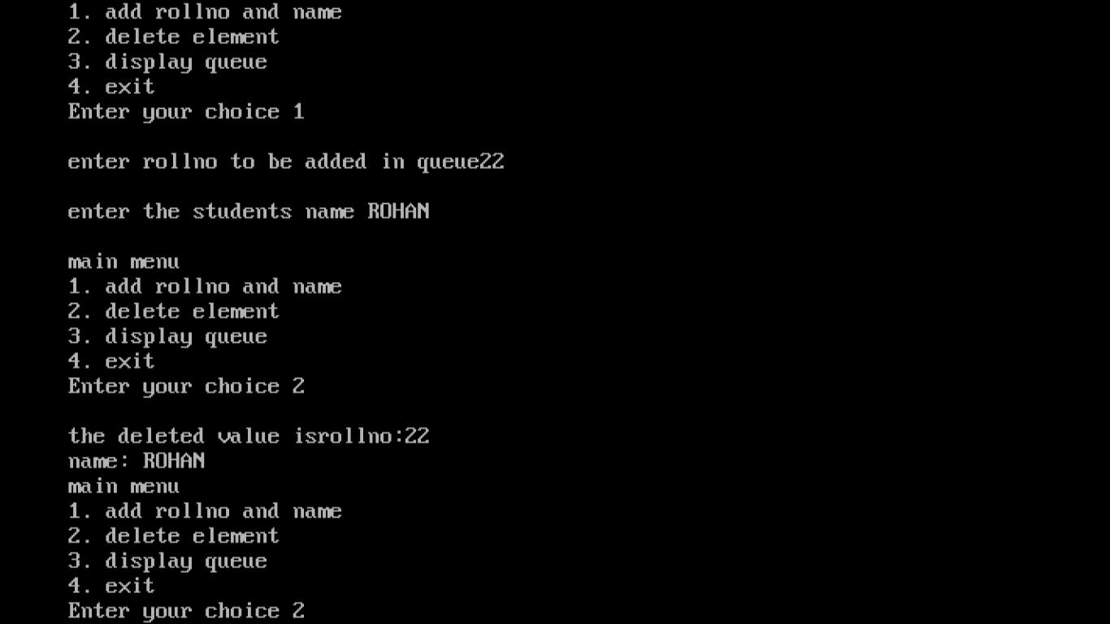

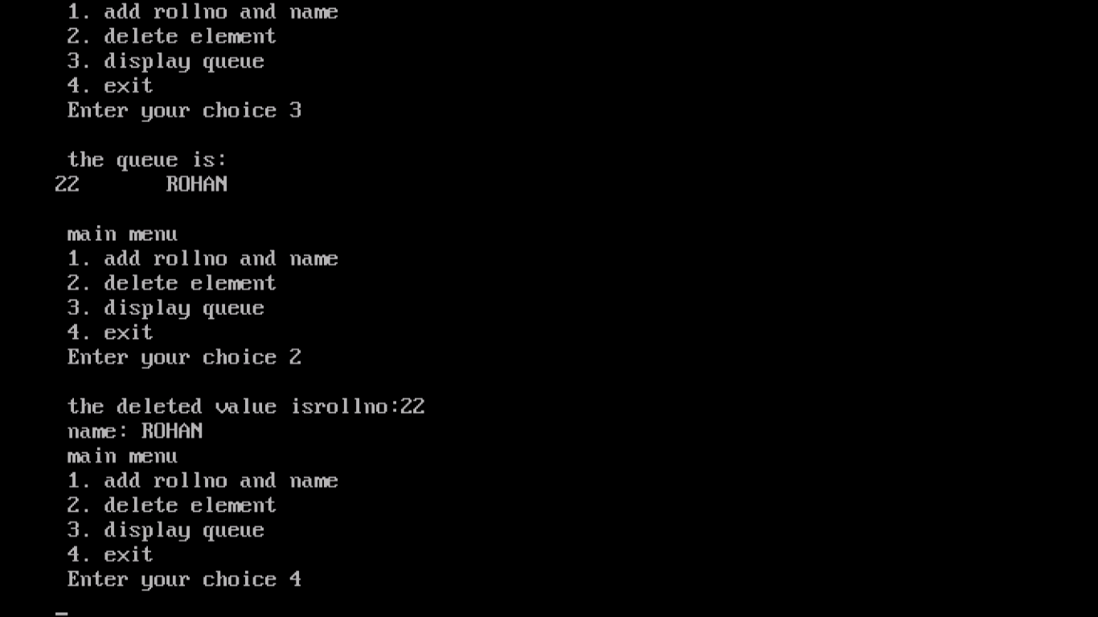

* **Linked list 11:**

/*Circular queue with integer*/

**#include<iostream.h>**

**#include<conio.h>**

**class queue**

**{**

**int data[10];**

**int front;**

**int rear;**

**public:**

**queue()**

**{**

**front=-1;**

**rear=-1;**

**}**

**void add();**

**void remove();**

**void display();**

**};**

**void queue::add()**

**{**

**if(rear==9 && front==0)**

**{**

**cout<<"\n overflow";**

**return;**

**}**

**int x;**

**cout<<"enterdata";**

**cin>>x;**

**if(rear==-1)**

**{**

**rear=0;**

**front=0;**

**}**

**else if(rear==9 )**

**{**

**rear=0;**

**}**

**else**

**{**

**++rear;**

**}**

**data[rear]=x;**

**}**

**void queue::remove()**

**{**

**if(front==-1)**

**{**

**cout<<"\n underflow";**

**return;**

**}**

**int x;**

**x=data[front];**

**if(front==rear)**

**{**

**front=-1;**

**rear=-1;**

**}**

**else if(front==9)**

**{**

**front=0;**

**}**

**else**

**{**

**front++;**

**}**

**cout<<"\n \t the deleted value is"<<x;**

**}**

**void queue::display()**

**{**

**int i;**

**if(front==-1)**

**{**

**cout<<"\n \t queue is empty";**

**}**

**else**

**{**

**for(i=front;i<=rear;++i)**

**{**

**cout<<data[i];**

**}**

**}**

**}**

**void main()**

**{**

**clrscr();**

**int choice;**

**queue q;**

**do**

**{**

**cout<<"\n main menu";**

**cout<<"1.add";**

**cout<<"2.remove";**

**cout<<"3.display";**

**cout<<"4.exit";**

**cout<<"enter your choice";**

**cin>>choice;**

**switch(choice)**

**{**

**case 1: q.add();**

**break;**

**case 2: q.remove();**

**break;**

**case 3: q.display();**

**break;**

**}**

**}while(choice!=4);**

**getche();**

**}**

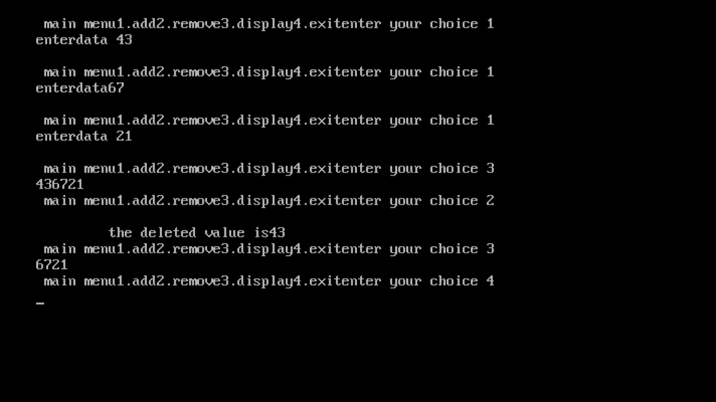

* **Linked list 12:**

/*Circular queue with character*/

**#include<iostream.h>**

**#include<conio.h>**

**#include<stdio.h>**

**#include<string.h>**

**class queue**

**{**

**char data[10][20];**

**int front;**

**int rear;**

**public:**

**queue()**

**{**

**front=-1;**

**rear=-1;**

**}**

**void add();**

**void remove();**

**void display();**

**};**

**void queue::add()**

**{**

**if(rear==9 && front==0)**

**{**

**cout<<"\n overflow";**

**return;**

**}**

**char x[20];**

**cout<<"enterdata";**

**gets(x);**

**if(rear==-1)**

**{**

**rear=0;**

**front=0;**

**}**

**else if(rear==9 )**

**{**

**rear=0;**

**}**

**else**

**{**

**++rear;**

**}**

**strcpy(data[rear],x);**

**}**

**void queue::remove()**

**{**

**if(front==-1)**

**{**

**cout<<"\n underflow";**

**return;**

**}**

**char x[20];**

**strcpy(x,data[front]);**

**if(front==rear)**

**{**

**front=-1;**

**rear=-1;**

**}**

**else if(front==9)**

**{**

**front=0;**

**}**

**else**

**{**

**front++;**

**}**

**cout<<"\n \t the deleted value is"<<x;**

**}**

**void queue::display()**

**{**

**int i;**

**if(front==-1)**

**{**

**cout<<"\n \t queue is empty";**

**}**

**else**

**{**

**for(i=front;i<=rear;++i)**

**{**

**cout<<data[i]<<endl;**

**}**

**}**

**}**

**void main()**

**{**

**clrscr();**

**int choice;**

**queue q;**

**do**

**{**

**cout<<"\n main menu";**

**cout<<"1.add";**

**cout<<"2.remove";**

**cout<<"3.display";**

**cout<<"4.exit";**

**cout<<"enter your choice";**

**cin>>choice;**

**switch(choice)**

**{**

**case 1: q.add();**

**break;**

**case 2: q.remove();**

**break;**

**case 3: q.display();**

**break;**

**}**

**}while(choice!=4);**

**getche();**

**}**

